# INSTITUTE OF MANAGEMENT SCIENCES │ PESHAWAR

Final Semester Examination ‐Take‐Home (online) ‐ Spring 2020

BS (SE) Human Computer Interaction

Instructor: Hamood ur Rehman Durrani Exam Date: August 23‐26, 2020

Duration: NA Total Marks: 30

***Attempt all questions.***

Question no 1 (10 marks)

Read the following scenario and answer the following questions:

1. Evaluate and comment on the use of color in the Alarm Control, Emergency Shutdown and Emergency Confirm panels (figure CS.2)
2. Evaluate and Comment on the use of layout and other elements in the control panels (figures CS.1, CS.2 and CS.3), including the way in which various visual elements support or hinder logical grouping and sequence.
3. Workings through the accident scenario explain why the various problems arise? Recognizing problems is part of the assessment.
4. Suggest potential ways of improving the interface to avoid a similar problem recurring.

The Nuclear reactor Scenario

*Note: This does not represent any real reactor although the sorts of problems it highlights do occur in real control*

*rooms.*

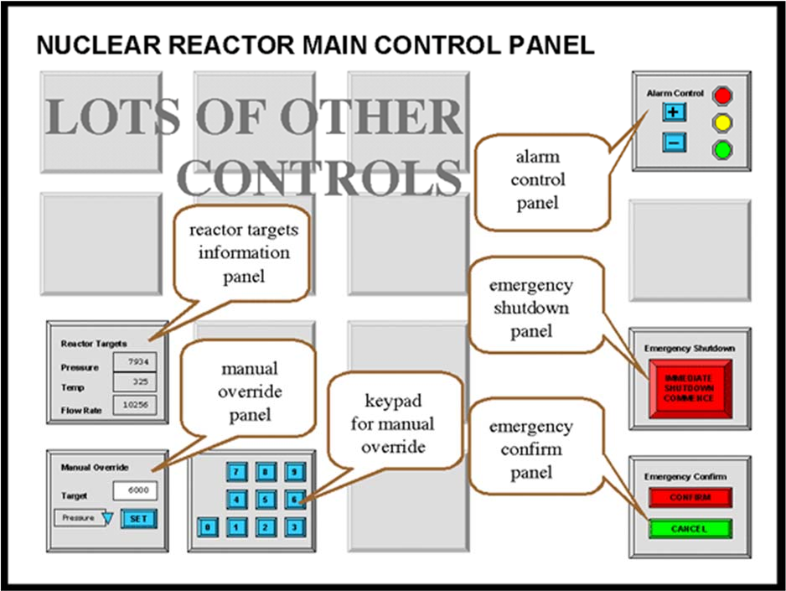Figure 1 shows a sketch of the control panel of a nuclear power plant. The actual panel is very large covering the whole wall of the control room and contains many sub‐panels and controls. The locations of some controls at the two ends of the panel are shown in figure CS.1, although it should be noted that the panel is much wider than the illustration.

Figure CS.1 ‐ nuclear reactor main control panel

# A few of the sub‐panels are important for this case study:

Alarm Control panel Emergency

Shutdown panel Emergency

Confirm panel Reactor Targets

display Manual Override panel

Numeric Keypad for the Manual Override panel

# Details of the first three of these are shown in figure CS.2 and details of the last three in figure CS.3.

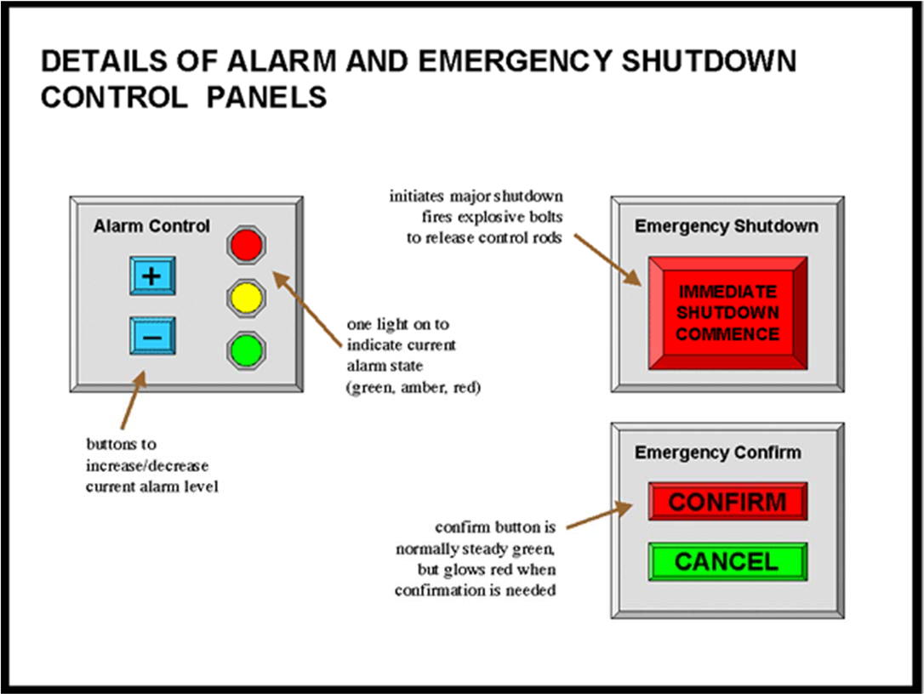

Figure CS.2 ‐ alarm and emergency sub‐panels

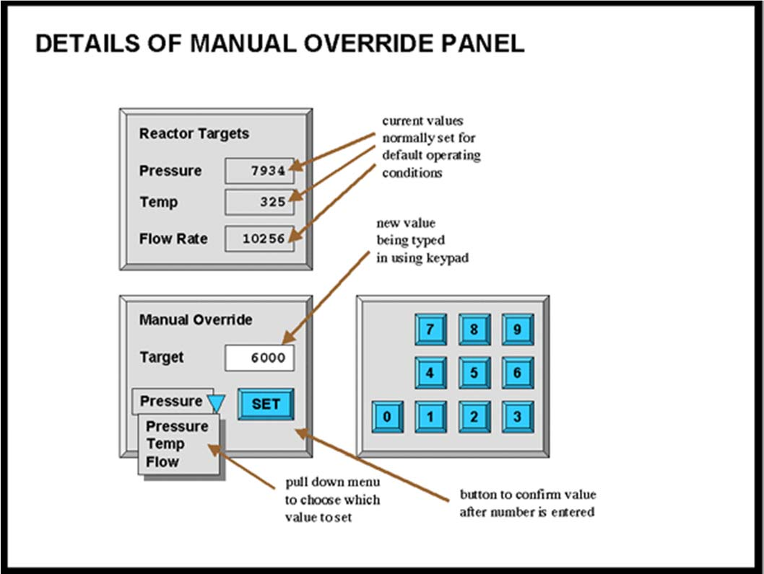

Figure CS.3 ‐ reactor targets display and manual override

How it works

Alarm State

The system can be in one of three alarm states: GREEN, AMBER or RED.

1. GREEN alarm state means everything is operating normally
2. AMBER alarm state is for when there is a minor problem with reactor operation. Workers in the reactor area are warned and take additional precautions, but no external services are involved.
3. RED alarm state is raised when the reactor is operating outside normal parameters and there is a possibility of external contamination. The police and other emergency services are alerted.

Typically AMBER state is raised once or twice a week and red state only a few times a year (so far only false alarms!). Raising a RED alarm unnecessarily causes significant inconvenience and cost both to the station staff and the external emergency services.

Original design of the alarm control panel

When the plant was commissioned, the alarm system controls worked as follows.

The current alarm state is indicated by which of the colored lights on the Alarm Control panel is lit (On). The '+' and '–' buttons on this panel increase or decrease the alarm state. Figure 4 shows a state transition network of

the effects of the '+' and '–' buttons on the state as the system was initially installed.

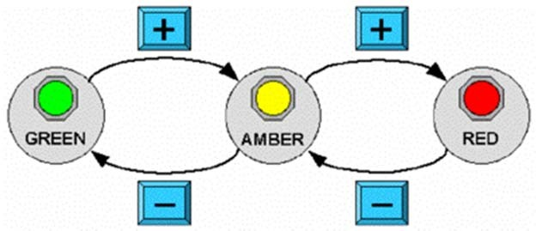

Figure CS.4 – STN for alarm state

Emergency Shutdown

When there is a very serious problem the operator can press the large red button labelled

IMMEDIATE SHUTDOWN COMMENCE on the Emergency Shutdown panel, which initiates an emergency

shutdown. This needs to be confirmed by pressing the CONFIRM button on the Emergency Confirm panel.

(This is to prevent accidental shutdown of the plant.) The CONFIRM button is normally green, but glows red

after the IMMEDIATE SHUTDOWN COMMENCE button has been pressed to remind the operator.

Emergency shutdown causes explosive bolts to blow that drive control rods into the reactor completely stopping

the nuclear reaction. Restarting the reactor after emergency shutdown may take several weeks and costs many millions of pounds in lost production and replacement of parts damaged during the shutdown procedure.

Reactor targets and manual override

The Reactor Targets panel shows the current target state of several reactor operating parameters. These are

normally set by an automatic control system to values that ensure optimal energy production.

In an extreme emergency the operator may need to control these targets. The Manual Override panel allows this.

Manual override is *only enabled* in RED alarm state.

To override a particular target the operator selects the desired target (Pressure, Temperature or Flow Rate) from a dropdown menu, types in the desired value using a numeric keypad and then confirms the value using the SET button. (The SET button is necessary to prevent part‐typed numbers being treated as the new value.)

Revised Alarm Control Operation

Some while after the plant was running a consultant suggested changing the operation of the Alarm

Control panel and the software and hardware was revised in line with his recommendations. The current design

works as follows.

Raising the alarm state from Green to Amber and back uses the '+' and '–' buttons as before. However now to raise the state from Amber to Red it is necessary to both press '+' and also confirm this by pressing

the CONFIRM button on the Emergency Confirm panel.

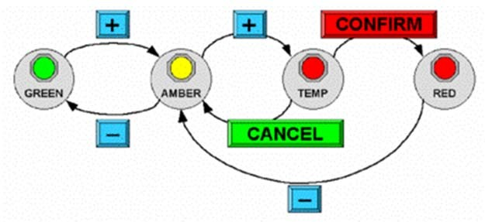Figure 5 shows the state transition network of the revised system.

Figure CS.5 – STN for revised alarm state

Emergency Scenario

Jenny, the Nuclear Power Plant operator has normal sight and no physical or perceptual impairments. Her shift

started at 11pm and it is now 5am in the morning. So far the plant has been operating within normal parameters and the current alarm state is therefore green

1. Jenny notices the core reaction rate has risen very rapidly
2. she realizes she must immediately change the reactor target pressure to correct this
3. she goes to the Alarm Control Panel on the far right of the main reactor control panel and presses '+' twice (as it is starting off in green state)
4. the Emergency Confirm button glows red
5. she moves across to the Manual Override panel on the far left of the main reactor control panel
6. she selects 'Pressure' from the pull down on the Manual Override panel
7. she types the new value '6000' using the keypad
8. she notices that the number on the Reactor Targets panel has not changed
9. she realizes she forgot to press the SET button on the Manual Override panel
10. she presses the SET button
11. the value still doesn't change
12. an automatic audio warning sounds "60 seconds to core meltdown"
13. she presses the SET button repeatedly
14. still the value doesn't change
15. she starts again, selects 'Pressure' from the pulldown, types 6000 and presses SET
16. still the value doesn't change
17. the audio warning says "30 seconds to core meltdown"
18. Jenny runs across the room to the Emergency Shutdown panel
19. "20 seconds to core meltdown"
20. she presses "Immediate Emergency Commence" button
21. the emergency confirm button glows red
22. "10 seconds to core meltdown"
23. she presses the "Emergency Confirm" button
24. she hears the crash of the explosive bolts sending the control rods into the reactor
25. the audio system announces "reactor shutdown successful"

Question 2 (6 marks)

A truly ubiquitous computing experience would require the spread of computational capabilities literally everywhere.

Another way to achieve ubiquity is to carry all of your computational needs with you everywhere, all the time. The field of *wearable computing* explores this interaction paradigm.

* 1. How do you think the first‐person emphasis of wearable computing compares with the other‐person, or environmental, emphasis of ubiquitous computing?
  2. What impact would there be on context‐aware computing if all of the sensors were attached to the individual instead of embedded in the environment?

Question 3 (7 marks)

Locate one source (through the library or the Web) that reports on empirical evidence on human limitations. Provide a

full reference to the source.

1. In one paragraph, summarize what the result of the research states in terms of a physical human limitation.
2. In a separate paragraph, write your thoughts on how you think this evidence on human capabilities impacts interactive system design.

Question 4 (7 marks)

This question involves you examining a range of input and output devices in order to understand how they influence interaction.

A typical computer system is comprised of a QWERTY keyboard, a mouse, and a color screen. There is usually some form of loudspeaker as well. You were taught how the keyboard, mouse and screen work ‐ if you don’t remember, read up on it.

1. What sort of input does the keyboard support?
2. What sort of input does the mouse support?
3. Are these adequate for all possible applications? If not, to which areas are they most suited?
4. Do these areas map well onto the typical requirements for users of computer systems?
5. If you were designing a keyboard for a modern computer, and you wanted to produce a faster, easier to use layout,
   1. What information would you need to know and
   2. How would that influence the design?